

DISCONTINUATION ALERT

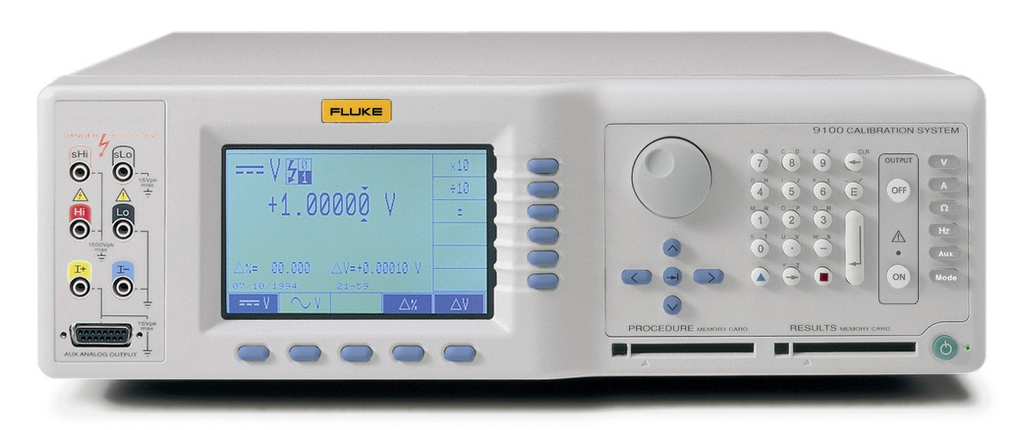
End of Life
&
Call for Last Orders
for the 9100 Multi Product Calibrator Series

Date: September 12, 2012

Fluke is announcing the immediate limited availability status and pending discontinuation of the 9100 MultiProduct Calibrator series.
Because of serious parts availability problems for the 9100, this product with all model and configurations is going on an immediate
Limited Availability Status
with a
Call for Last Orders for ALL customers.
This also includes all available options and accessories except for the 9100-200 Current Coil, which will continue to be available as an accessory to the 55XXA Calibrators.
The last order date will be no later than 30 November 2012.
Be aware that this last order date is highly impacted by our component supplies and may be SOONER if order quantities exceed our expectations & plans or ability of fill the order.
Please also note that orders will be accepted on a first come basis as long as component supply lasts while order quantities can be limited.
Check with order administration prior to quoting or placing orders for more than single unit quantities.
At this time we anticipate all mainframe and option configurations and accessories will remain available for this last order event. The new 5502A MultiProduct Calibrator replaces the 9100 in this market place and can be considered a viable and an improved replacement model.
Plan of Action:
We need your help to make this end of life notification go smoothly as we collect all remaining 9100 and 9100E orders. Here is how you can help:
9100 SERIES ITEMS TO BE DISCONTINUED

For your reference, here are the details of items which will NOT be orderable after
1 December 2012:

Model | Item No | Item Description | Class
9100 | 1583873 | 9100, UNIVERSAL METER CALIBRATION SYSTEM, WITH THERMOCOUPLE POD | mainframe
9100/WS1 | 2797644 | 9100, UNIVERSAL METER CALIBRATOR W/ MET/CAL LITE | mainframe
9100E | 2061487 | 9100E,PRE-CONFIGURED METER CALIBRATOR | mainframe
9100E/WS1 | 2797659 | 9100E, PRE-CONFIGURED METER CALIBRATOR W/ MET/CAL LITE | mainframe
9100-100 | 1583942 | 9100-100, 0.25 PPM STABILITY CRYSTAL REFERENCE OPTION (INSTALLS INTERNALLY) | option
9100-135 | 1583956 | 9100-135, INSULATION/CONTINUITY TESTER CAL OPTION (INSTALLS INTERNALLY) | option
9100-250 | 1583974 | 9100-250, 250 MHZ OSCILLOSCOPE CALIBRATION MODULE OPTION (INSTALLS INTERNALLY) | option
9100-600 | 1583988 | 9100-600, 600MHZ SCOPE OPTION | option
9100-PWR | 1583995 | 9100-PWR, POWER CALIBRATION OPTION (INSTALLS INTERNALLY) | option
9100-10 | 1583886 | 9100-10, BLANK 256K BYTE, PROGRAMMABLE (FLASH) MEMORY CARD OPTION | accessory
9100-30 | 1583899 | 9100-30, BLANK 256K BYTE, STAT IC (SRAM) MEMORY CARD OPTION | accessory
9100-60 | 1583917 | 9100-60, SOFT CARRYING CASE | accessory
9100-65 | 1583921 | 9100-65, RUGGEDIZED TRANSIT CASE (REQUIRES OPT 60) | accessory
9100-90 | 1583939 | 9100-90, RACK MOUNT KIT | accessory
9100-PROC1 | 2061493 | 9100-PROC1,METER CALIBRATION PROCEDURES LIBRARY | accessory

- Contact your 9100 calibrator customers and inform them of the end of life on 1 December 2012 of both the 9100 series mainframes, options and accessories. Have them plan their final purchases accordingly.
- All units will have their normal warranty.
- Assure customers that as per Fluke’s policy full service and repair of these calibrators will continue for at least five years after production ceases,
- Calibration services will continue indefinitely beyond that time.
- Future requirements for calibrators will be satisfied by the new Fluke 5502A series of MultiProduct calibrators.

If you have a customer that requires further information on the availability and end of life of these products please do not hesitate to contact either product or sales management.
Thank you for your assistance, Good Luck and Successful Selling
Joost Korthout / Lawrence Rainbird
Regional Product Marketing Managers

